MA441Hon Team Project 1

Fourier Series Representation for Rocket Density Measurements with Altitude

**October 11, 2016**

**Group F**

**Group Members**

Stirling Brandt

Jason Koch

Brennan McCann

Embry-Riddle Aeronautical University

Daytona Beach, FL 32114

**Introduction**

A Fourier series is a commonly used series which represents the expansion of a periodic function in terms of sine and cosine. While it is an infinite series and thus impossible for computers to use in full, when only a few terms are considered its usefulness extends to several applications of data analysis. For this project, atmospheric density readings taken by a rocket during its trip through the atmosphere were analyzed. During the data recording time of 850 to 900 seconds after takeoff, density measurements vary significantly. Particularly due to noise and extraneous data, the readings do not represent an observable function of density with altitude. Using a Fourier series approximation, however, it is possible to produce a function that represents the data points as a curve. Due to the nature of the series, any amount of terms can be included in the summation. The resulting calculation of the curve will change as more terms in the Fourier series are added. For this data set, 5, 7, and 10 terms were used to approximate the representative function. In addition, both a cosine and a full Fourier series were calculated and compared. The usefulness of such analysis can be extended to any number of included terms or any set of data points.

**Methodology**

In the determination of both the Fourier cosine series and full Fourier series the values for a0, an, and bn are typically determined by an integral featuring a function f(x).However, given that there is no function given for the rocket data set, the integrals were evaluated as a series. The transition can be found below.

$$\int_{a}^{b}{f(x)}=\sum_{x=a}^{b}{f(x)}δx$$

For the values from a to b, the integral of the function is equal to the summation of all f(x) values multiplied by a very small change in x. For the cosine series, it was only necessary to calculate a0 and an. The integrals for these values are given as

$$b_{n}=\frac{1}{L}\int_{-L}^{L}{f(x)\sin{\frac{nπx}{L}}dx}$$

$$a_{n}=\frac{1}{L}\int_{-L}^{L}{f(x)\cos{\frac{nπx}{L}}dx}$$

$$a_{0}=\frac{1}{2L}\int_{-L}^{L}{f(x)dx}$$

In series notation, these would be given by

$$b_{n}=\frac{1}{L}\sum_{x=-L}^{L}{f(x)\sin{\frac{nπx}{L}}}δx$$

$$a_{n}=\frac{1}{L}\sum_{x=-L}^{L}{f(x)\cos{\frac{nπx}{L}}}δx$$

$$a_{0}=\frac{1}{2L}\sum_{x=-L}^{L}{f(x)}δx$$

In this case, L would vary over a 50s time frame from 850 to 900 seconds in the flight for the given data set. The full Fourier series would be given by

$$g\left(x\right)=a_{0}+\sum_{0}^{n}{a_{n}\cos{\frac{nπx}{L}}+}b_{n}\sin{\frac{nπx}{L}}$$

Substituting the values for a0, an, and bn, the Fourier series would be given by

$$g\left(x\right)=\frac{1}{2L}\sum_{x=-L}^{L}{f(x)}δx+\sum_{0}^{n}{\left(\frac{1}{L}\sum_{x=-L}^{L}{f(x)\cos{\frac{nπx}{L}}}δx\right)\cos{\frac{nπx}{L}}+}\left(\frac{1}{L}\sum_{x=-L}^{L}{f(x)\sin{\frac{nπx}{L}}}δx\right)\sin{\frac{nπx}{L}}$$

Using a similar fashion, the cosine series would be given by

$$g\left(x\right)=\frac{1}{2L}\sum_{x=-L}^{L}{f(x)}δx+\sum_{n=0}^{n}{\left(\frac{1}{L}\sum_{x=-L}^{L}{f(x)\cos{\frac{nπx}{L}}}δx\right)\cos{\frac{nπx}{L}}}$$

For the cosine series expansion, it is possible to simply integrate over the data once and multiply by two for each coefficient. This works because for a cosine series the data is extended as an even periodic function, so the data will be symmetrical about the y axis and both halves of the integration will be equal. This does not work for the full Fourier series because instead of being reflected, the data is copied and translated for its extension. Due to this, it is necessary to integrate over the data twice, with the cosine and sine functions within the integration shifted by one period. The equations from these simplifications can be seen below.

Cosine series:

Fourier series:

This calculation can be completed in MATLAB through a pair of nested for loops, calculating the values of the coefficients over the range of t values from 850s to 950s and determining those values for each of the n number of terms (5, 7, and 10 in this case).

**Results**

Figures 1 through 6 display the various Fourier series plotted over top the data provided.

**Figure 1: Cosine Series Approximation with 10 Terms**

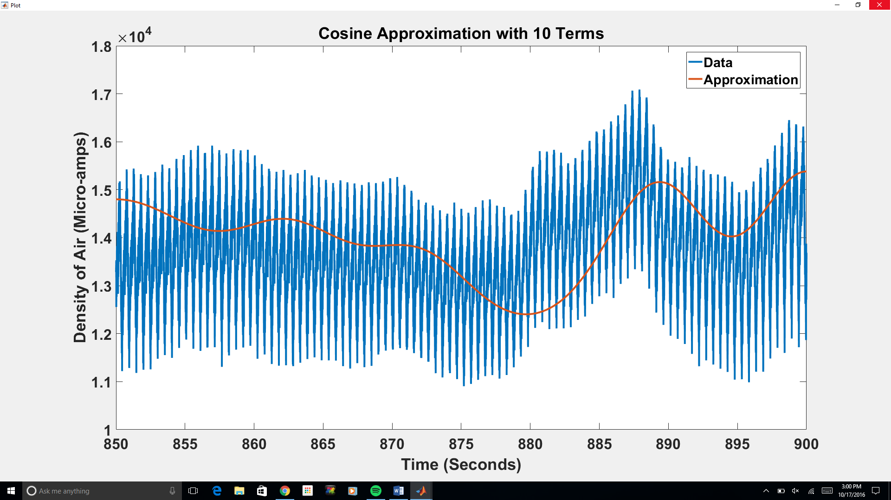

**Figure 2: Cosine Series Approximation with 7 Terms**

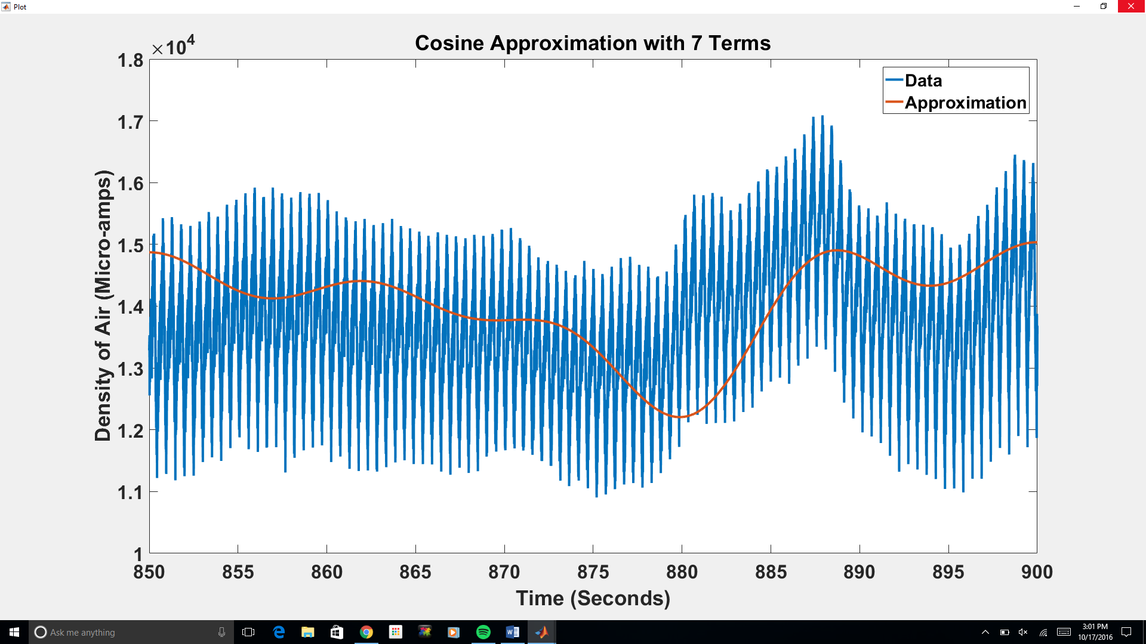

**Figure 3: Cosine Series Approximation with 5 Terms**

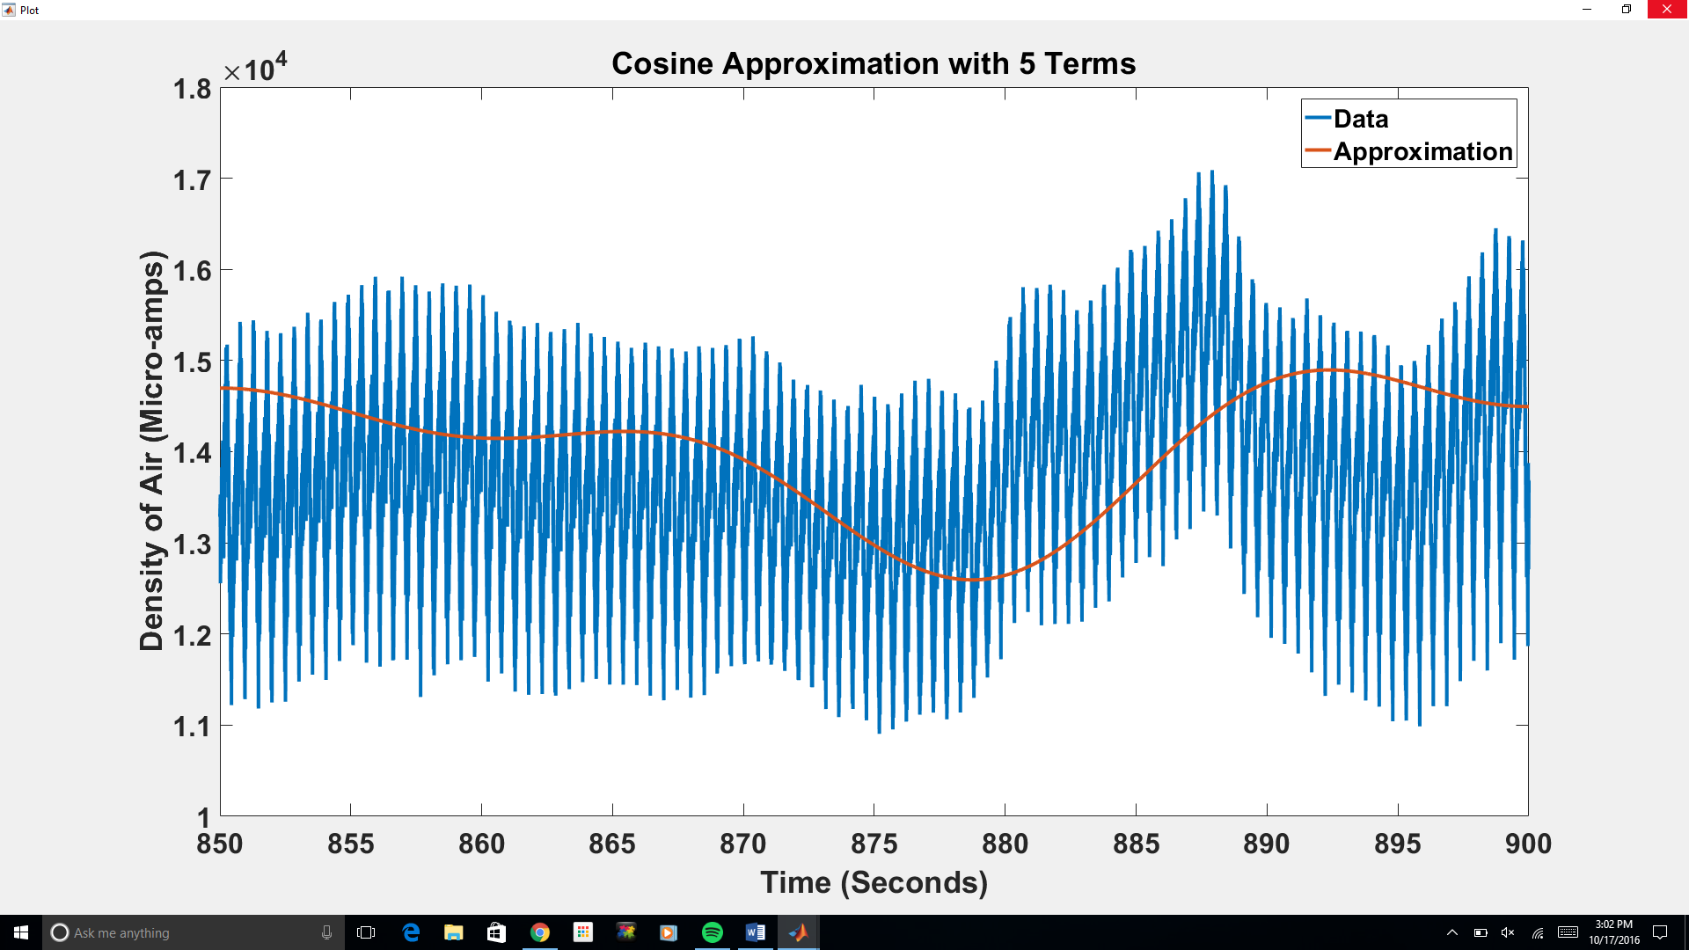

**Figure 4: Full Fourier Series Approximation with 10 Terms**

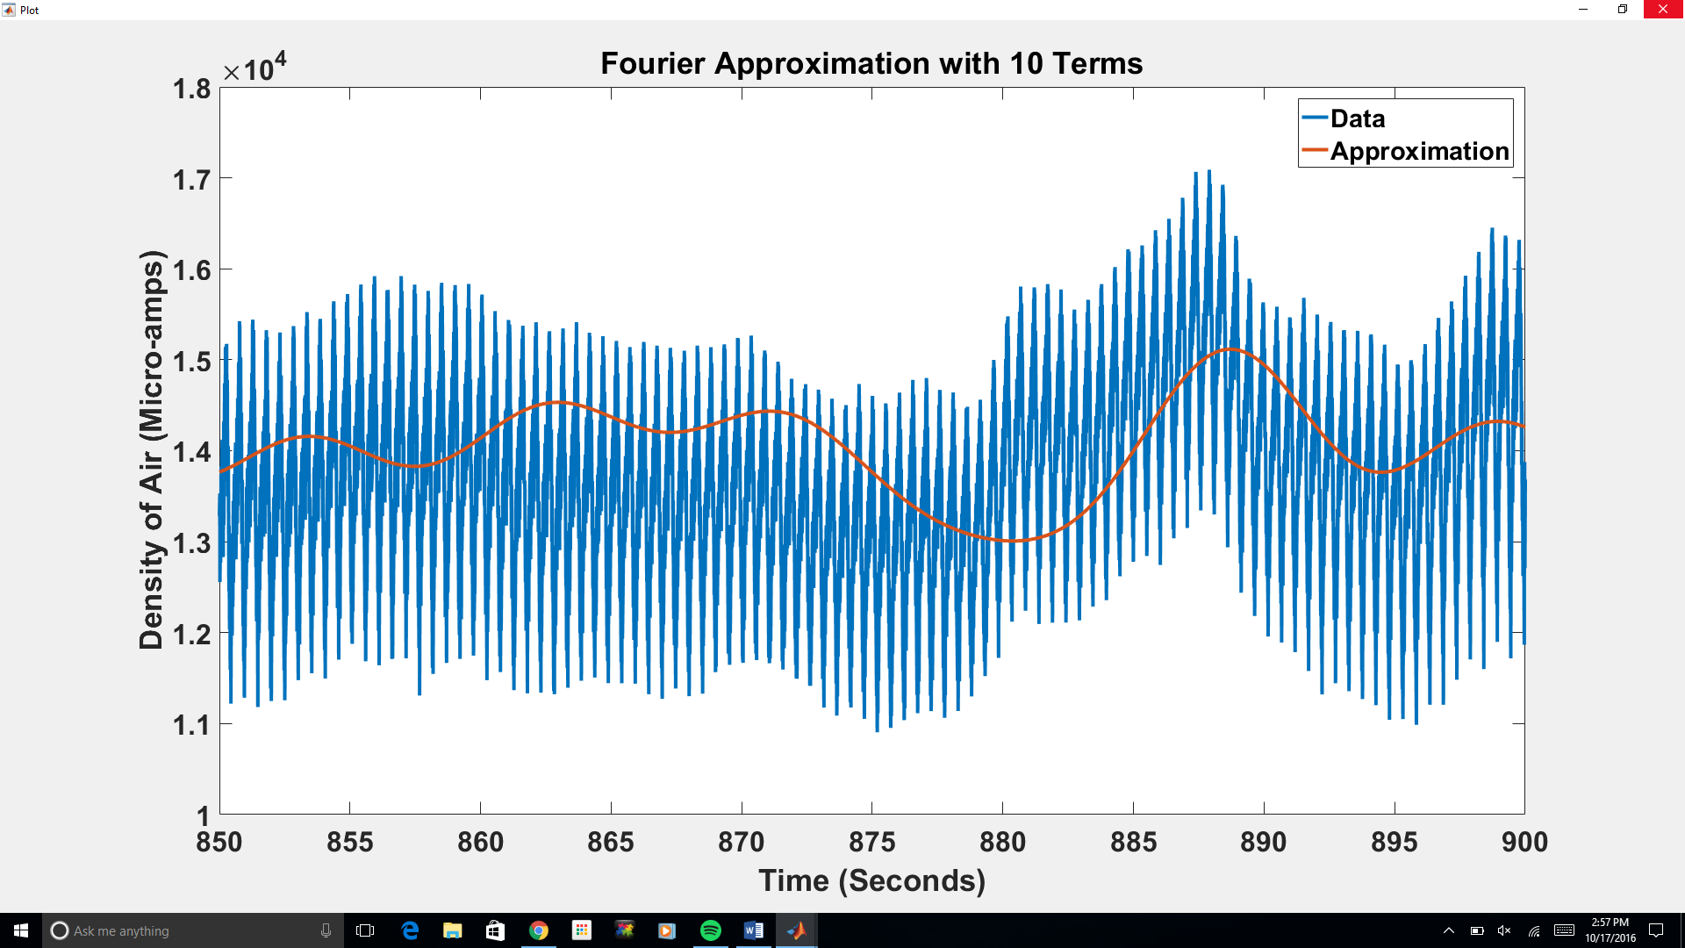

**Figure 5: Full Fourier Series Approximation with 7 Terms**

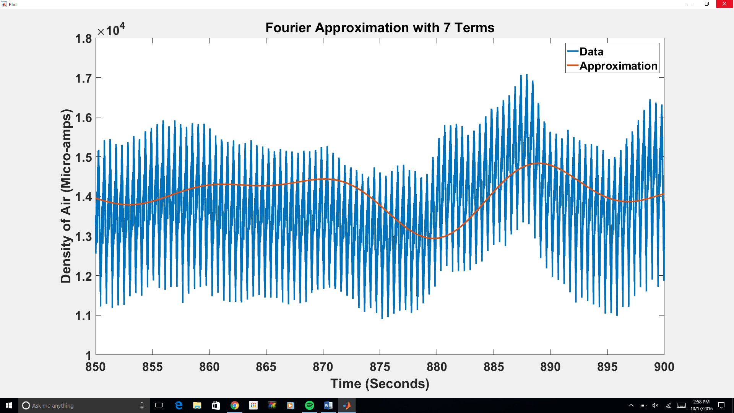

**Figure 6: Full Fourier Series Approximation with 5 Terms**

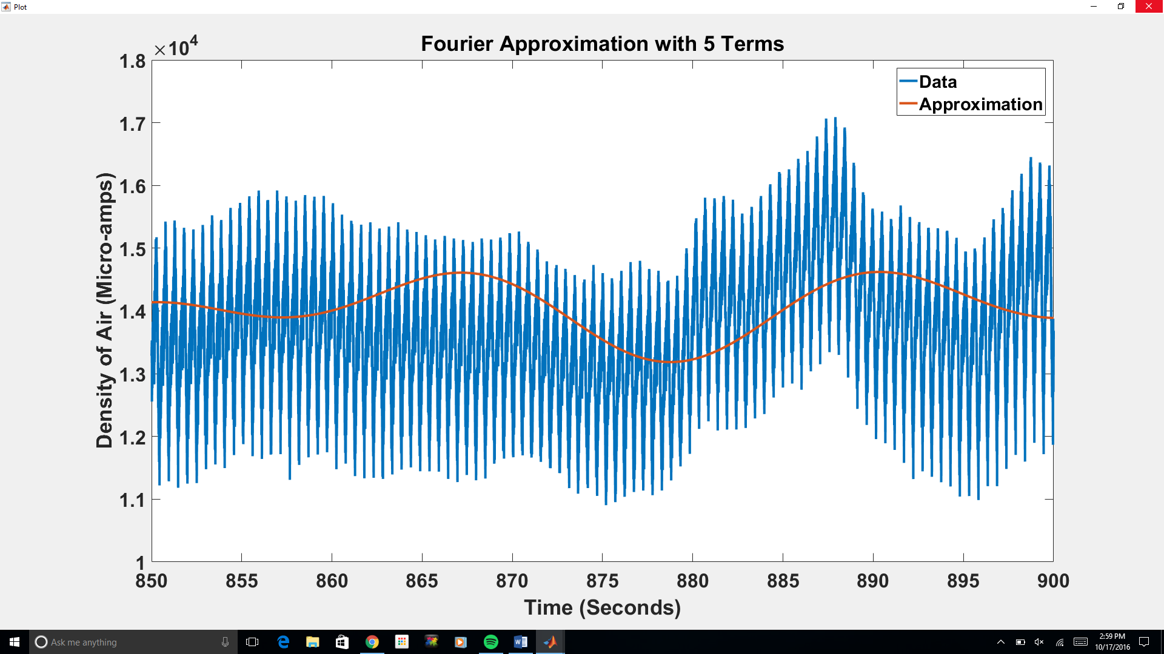

**Discussion**

The results presented offer an opportunity for comparison between the effectiveness of using a Fourier series versus using a Cosine series. For all the number of terms, the Fourier approximation most closely resembles the data. Seeing as a Cosine series neglects the added sine term that the Fourier series accounts for, the Fourier series is more precise. A Cosine series only reflects the behavior of the data set that behaves like an even function, hence why the presented Fourier series can reflect more subtle changes in the data set. For example, looking at the 10 term Fourier series and 10 term Cosine series, the Fourier series more closely follows the data from 850s to 850s, increasing to a local maximum. However, in the Cosine series, this series is decreasing over this interval from what appears to be a maximum at 850s. This would make sense considering that the Cosine must be symmetrical centered about 850s, but it ultimately contributes to uncertainty.

Whether dealing with Fourier series, Cosine series, or Sine series, the essential characteristic that determines how closely the model fits the data is the number of terms used. It is impossible to use an entire infinite series, as it would literally take forever, but a fast computer can do a million or even a billion terms in a somewhat reasonable timespan. The limiting factor isn’t what can be done, but rather how useful the model is. A model that perfectly fits the data does no good whatsoever, because the data already does that. What is useful is a smooth curve that fits the data reasonably well but still filters out noise. As can be seen from the plots, ten terms is enough to fit the data very closely, but still be a smooth curve. One hundred terms, on the other hand, is a very rough curve and is clearly being affected by noise. Figures 7 and 8 are representations of this scenario.

**Figure 7:Full Fourier Series Approximation with 100 Terms**

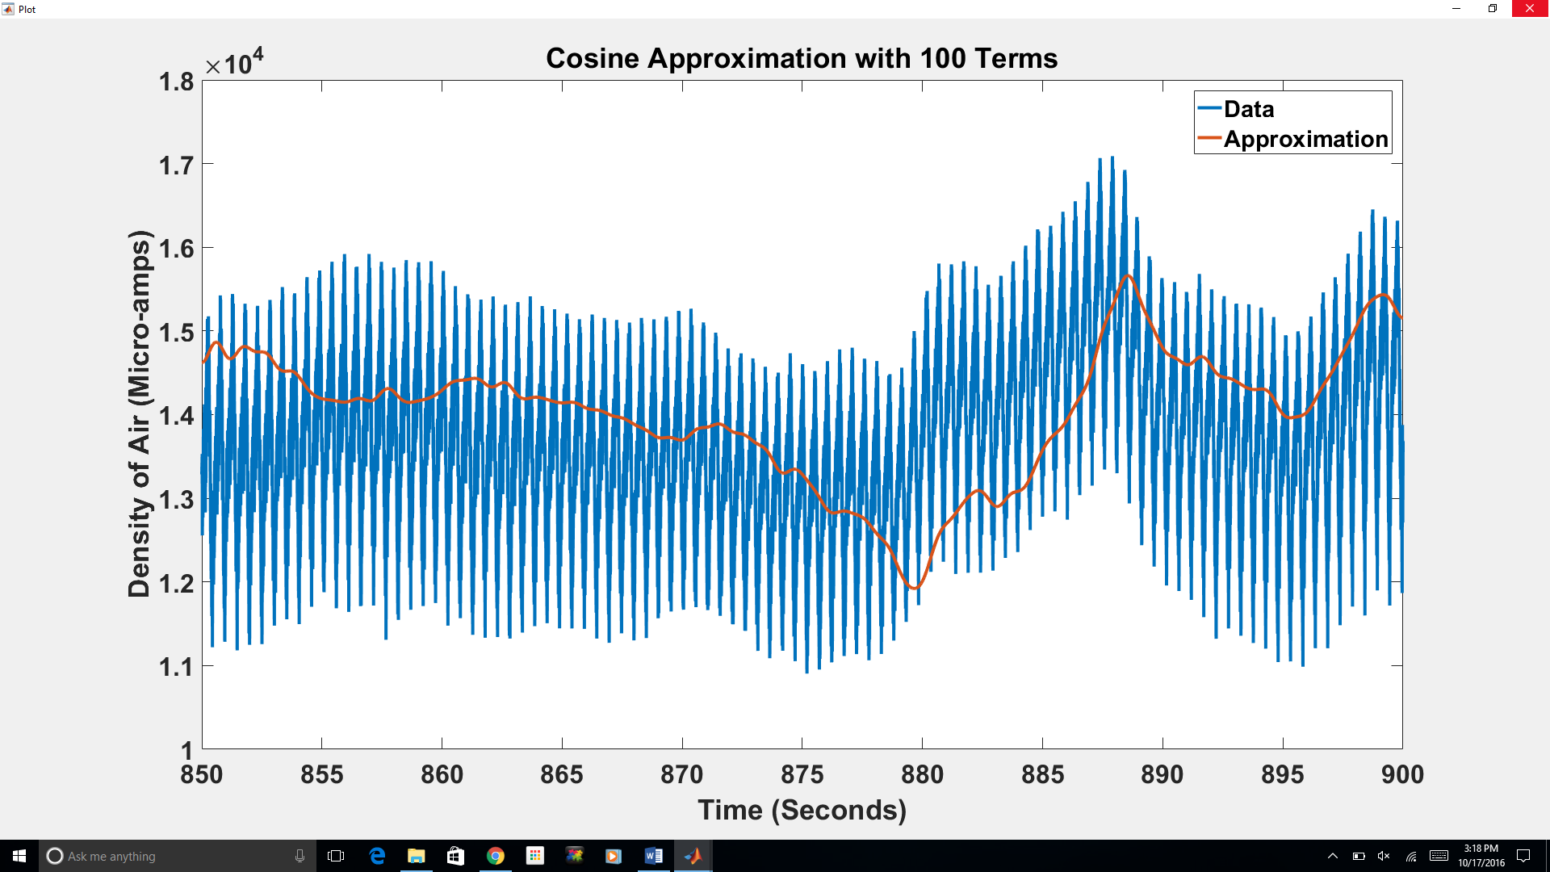

**Figure 8:Full Fourier Series Approximation with 100 Terms**

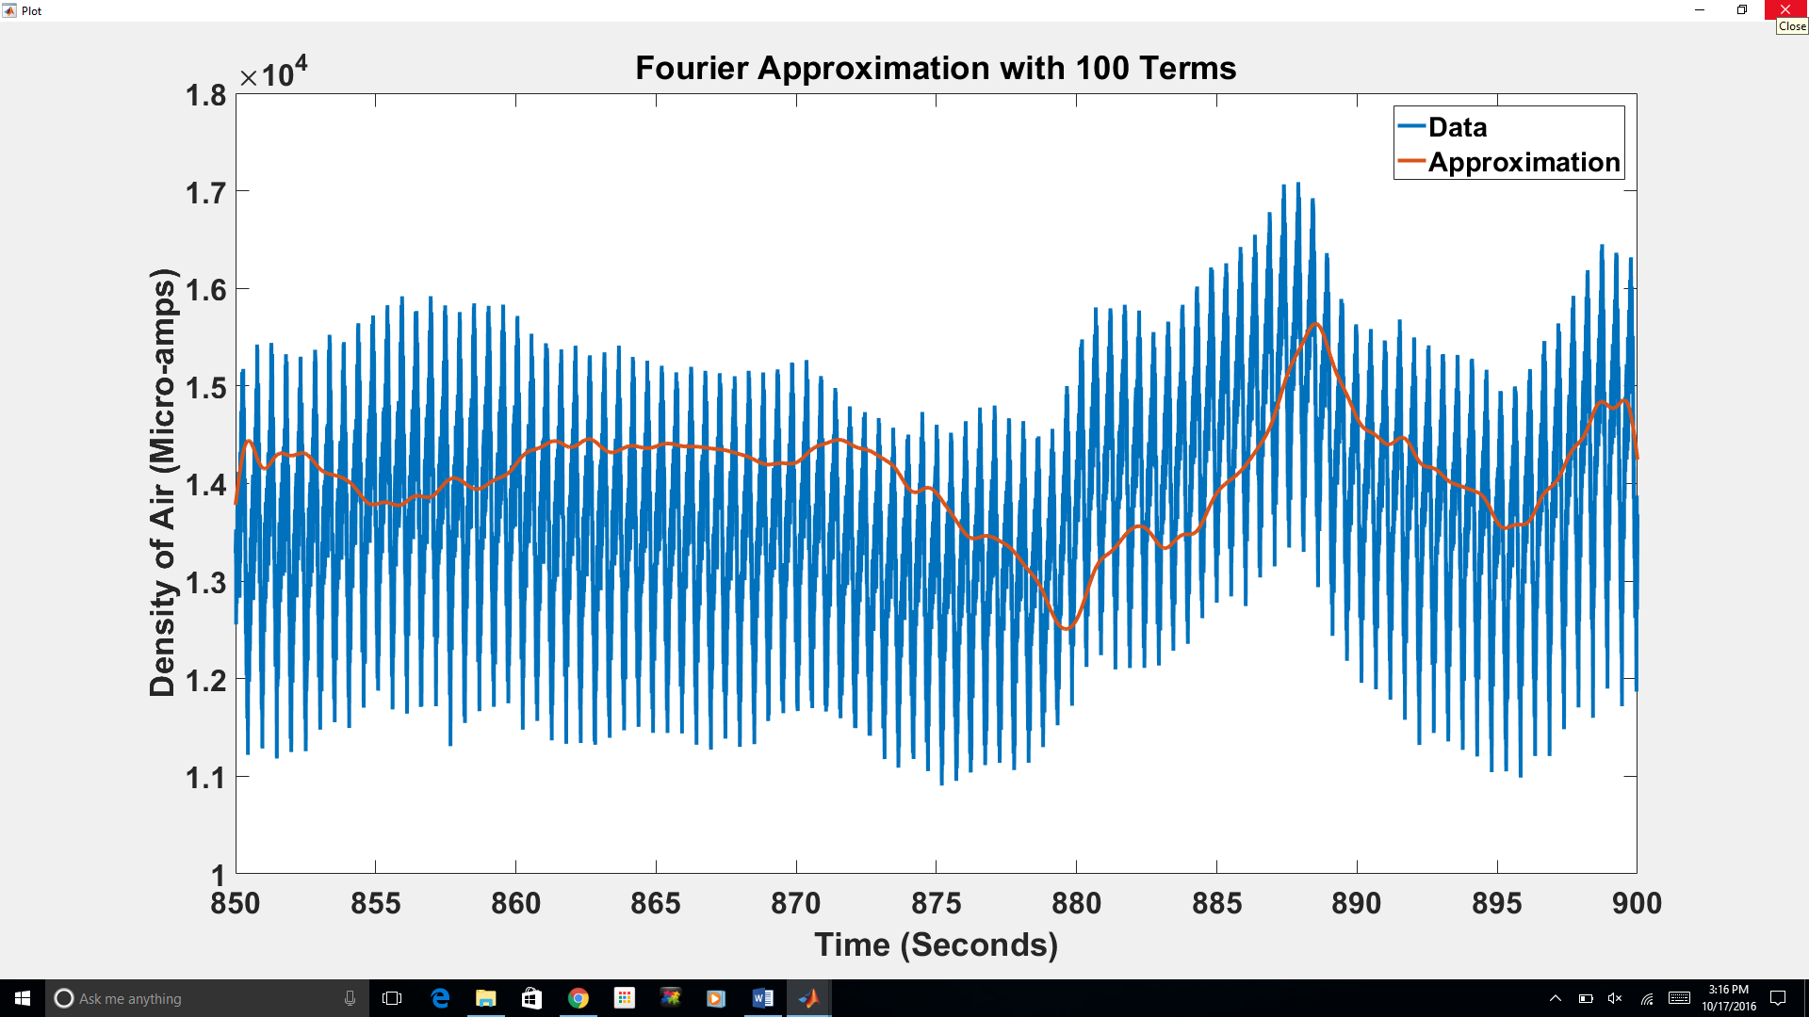

In modern times, a lot of the undiscovered aspects of physics have proven exceedingly complicated to model. For this reason it is necessary to collect enormous amounts of data to help with developing formulae. The problem with this is that huge amounts of data will always have a large amount of noise. Fourier series are very useful for helping to filter out that noise. The Large Hadron Collider produces 300 GB of data every second, so very powerful methods are needed to process it and find trends. Fourier series are among the methods used (Schörner-Sadenius, 2015). This is only one example of the implementation of one of the most powerful tools in mathematics.

**Conclusion**

Significance of a Fourier Series-

Variability of number of terms-

Common procedure for data (Adaptability)-

Works Cited

Schörner-Sadenius, T. (2015). *The Large Hadron Collider: Harvest of Run 1*. Heidelberg ; New York, NY: Springer.

**Appendix**

% Rocket Fourier

% Creates and plots a fourier sine series with variable number of terms for

% MA 441 rocket data

% Load data

Data = xlsread('Rocket_Data');

% Calculate first 100 coefficients

Coeffs = zeros(3,101);

for n = 0:100

% Treat term 0 differently

if n == 0

% Take the average of the data as a0

a = sum(Data(:,1)) / length(Data);

ac = a;

% Set b0 as 0

b = 0;

else

a = 0;

b = 0;

time = 850;

for t = 1:length(Data)

% Take the integral of the data's periodic extension multiplied

% by cos(n*pi*x/L) from 800 to 900

a = a + Data(t,1) * cos(n*pi()*Data(t,2)/50) * (Data(t,2) - time);

a = a + Data(t,1) * cos(n*pi()*(Data(t,2)-50)/50) * (Data(t,2) - time);

% Take the integral of the data's periodic extension multiplied

% by sin(n*pi*x/L) from 800 to 900

b = b + Data(t,1) * sin(n*pi()*Data(t,2)/50) * (Data(t,2) - time);

b = b + Data(t,1) * sin(n*pi()*(Data(t,2)-50)/50) * (Data(t,2) - time);

time = Data(t,2);

end

time = 850;

for t = 1:length(Data)

% Take the integral of the data multiplied by cos(n*pi*x/L)

ac = ac + Data(t,1) * cos(n*pi()*Data(t,2)/50) * (Data(t,2) - time);

time = Data(t,2);

end

% Multiply by 2/L for the cosine series coefficients and 1/L for

% the Fourier series

ac = ac*2/50;

a = a/50;

b = b/50;

end

% Store coefficients in a matrix

Coeffs(1, n+1) = a;

Coeffs(2, n+1) = b;

Coeffs(3, n+1) = ac;

end

% Call simple GUI to select number of terms to plot

termselector(Data, Coeffs)

% Rocket_Fourier_GUI

function termselector(Data, Coeffs)

% Create frame

frame = figure('Resize', 'Off');

set(frame,'MenuBar','none');

set(frame,'Name','Term Selector');

set(frame,'NumberTitle','off');

set(frame,'Position', [100,100,200,260])

% Create edit box to show number of terms

terms = uicontrol('Style', 'Edit', 'Units', 'Normalized', 'Position', [.4,.5,.2,.1], 'String', '10');

% Create button to plot fourier approximation

button = uicontrol('Style', 'Pushbutton', 'Units', 'Normalized', 'Position', [.3,.3,.4,.1], 'String', 'Plot Fourier');

set(button, 'Callback', {@forplotter, Data, Coeffs, terms})

% Create button to plot cosine approximation

button = uicontrol('Style', 'Pushbutton', 'Units', 'Normalized', 'Position', [.3,.1,.4,.1], 'String', 'Plot Cosine');

set(button, 'Callback', {@cosplotter, Data, Coeffs, terms})

end

% Callback for plot button

function forplotter(hObject, eventdata, Data, Coeffs, terms)

% Extract number of terms to plot

num = str2double(get(terms, 'String'));

% Calculate points to fit fourier approximation

ys = [];

for t = 850:.001:900

y = Coeffs(1,1);

for n = 2:num + 1;

y = y + Coeffs(1,n) * cos(n*pi()*t/50) + Coeffs(2,n) * sin(n*pi()*t/50);

end

ys = [ys,y];

end

t = 850:.001:900;

% Create a new axes in a new frame

frame2 = figure('Resize', 'Off');

set(frame2,'MenuBar','none');

set(frame2,'Name','Plot');

set(frame2,'NumberTitle','off');

set(frame2,'Position', [300,300,400,300]);

% Plot fourier approximation and data

plot(Data(:,2),Data(:,1),t,ys)

plottitle = sprintf('Fourier Approximation with %d Terms', num);

title(plottitle)

xlabel('Time (Seconds)')

ylabel('Density of Air (Micro-amps)')

legend('Data', 'Approximation')

end

% Callback for cosine plot button

function cosplotter(hObject, eventdata, Data, Coeffs, terms)

% Extract number of terms to plot

num = str2double(get(terms, 'String'));

% Calculate points to fit cosine approximation

ys = [];

for t = 850:.001:900

y = Coeffs(3,1);

for n = 2:num + 1;

y = y + Coeffs(3,n) * cos(n*pi()*t/50);

end

ys = [ys,y];

end

t = 850:.001:900;

% Create a new axes in a new frame

frame2 = figure('Resize', 'Off');

set(frame2,'MenuBar','none');

set(frame2,'Name','Plot');

set(frame2,'NumberTitle','off');

set(frame2,'Position', [300,300,400,300]);

% Plot Cosine approximation and data

plot(Data(:,2),Data(:,1),t,ys)

plottitle = sprintf('Cosine Approximation with %d Terms', num);

title(plottitle)

xlabel('Time (Seconds)')

ylabel('Density of Air (Micro-amps)')

legend('Data', 'Approximation')

end